Read out of KPI’s:

Accurate Application Portfolio:

Sheet 1 will have the details which will give accurate Application Portfolio to understand the current state of Infrastructure.

Sheet 2 will have Pivot which will give clear summary statistics of maximum connections which is leveraged in this analysis.

Sheet 3: A Bar chart will give visual affinity of the group of Computers which are closely related and any impact on 1 will impact the other computers functionality and business impact.

Sheet 1 of the excel with Cleaned up Affinity Report generated from Tool and other manual modes.

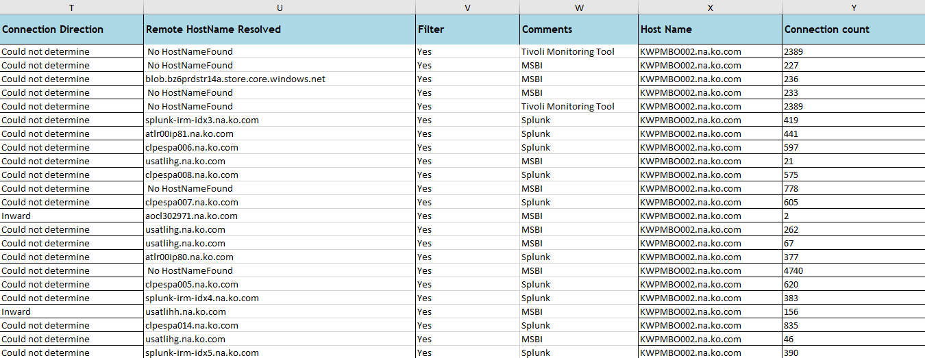

Sheet 2: will have a Pivot built using the columns like Host Name, Remote HostName Resolved, Connection Count and Connection Direction.

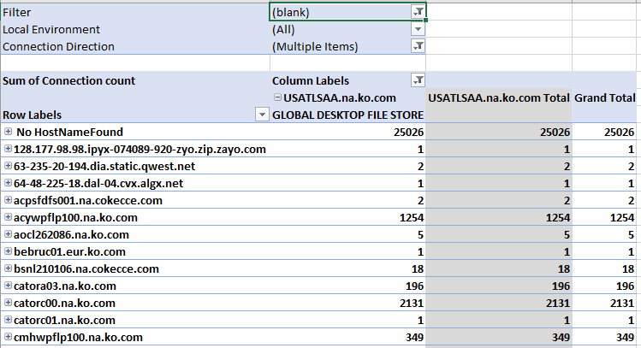

Sheet 3: Will have Bar chart or we can use Tableau or any other Visualization tool to build the Bar Chart.

